5 – Git-HOL Hands-On

Step1: Checking if the master is clean
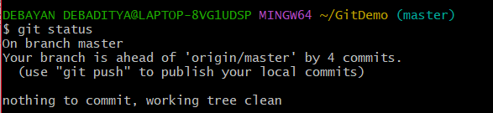
Step 2: Listing all available branches
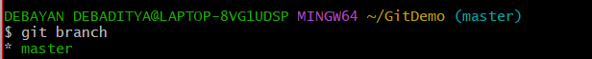
Step 3: Pulling down the remote updates
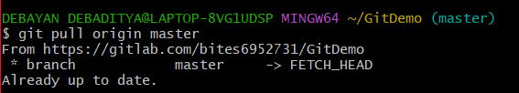
Step 4: Pushing the local merge commits to GitLab
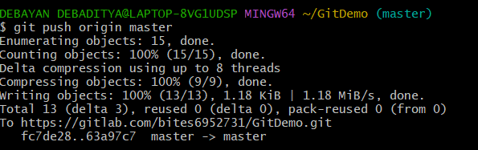

Step 5: Observing the online changes
